Eton Wick C of E First School
English Overview 2020 - 2021

Reception
 | Autumn 1 | Autumn 2 | Spring 1 | Spring 2 | Summer 1 | Summer 2
Topic | Rainforest/animals | Space | Healthy eating | Africa | Summer | Fairytales
Book | 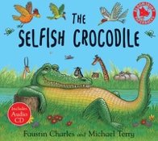  The selfish crocodile  Faustin Charles  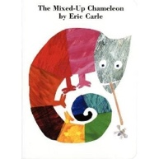  The Mixed-Up Chameleon  Eric Carle | 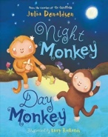  Night Monkey, Day Monkey  Julia Donaldson  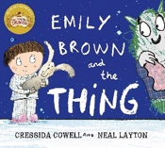  Emily Brown and the thing  Cressida Cowell | 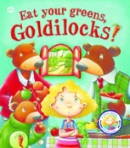  Eat your greens Goldilocks!  Steve Smallman  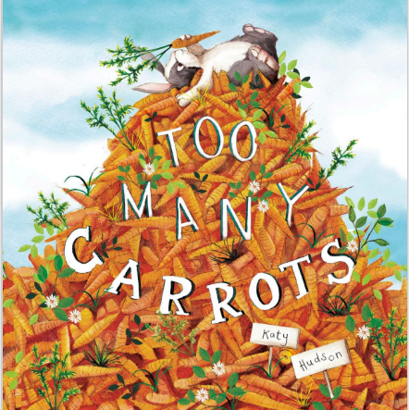  Too many carrots  Katy Hudson | 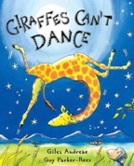  Giraffes can’t dance  Giles Andreae  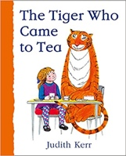  The Tiger Who Came to Tea  Judith Kerr | 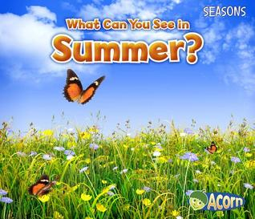  What can you see in summer?  Sian Smith  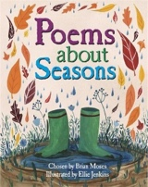  Poems about seasons  Brian Moses | 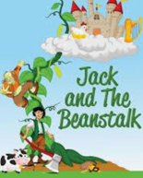  Jack and the Beanstalk  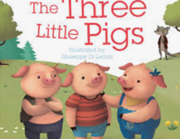  The three little pigs
Genre | Pattern and rhyme  -------  Story – fantasy world | Recount  ---------  Labels, lists and captions | Story with a familiar setting  --------------  Instructions | Labels, lists and captions  -----------  Pattern and rhyme | Poems to perform  --------------  Non-fiction | Traditional tales  ----------  Pattern and rhyme

