Eton Wick C of E First School
Phonics information for parents

What is phonics and why do we teach it?
The ability to read and write is a key life skill that paves the way to success at school and in the world beyond. Phonics is a way of teaching children to read skillfully, and is a way of decoding written letters or spoken sounds.
In phonics, children are taught how to: recognise the sounds that each individual letter makes;
- identify the sounds that different combinations of letters make – such as ‘sh’ or ‘oo’; and blend those sounds together from left to right to make a word.
Children can then use this knowledge to ‘decode’ new words that they see or hear. This is the first important step to learning to read.

At Eton Wick, we want to give the children all of the skills they need in order to develop into readers who are able to go on to read and understand any kind of text fluently and confidently, with enjoyment. We use a scheme called Read, Write Inc. to teach children phonics.

To begin, children are taught individual sounds daily during 'Speedy Sounds' sessions. After these have been learnt, children begin to learn how to blend these sounds into words. These sessions are repeated while new sounds are learned and are continually incorporated to ensure children have a secure knowledge

Click below to listen to how to pronounce each of the sounds in Set 1, 2 and 3
Sound Pronunciation Guide

Green words
'Green' words are phonetically decodable words that the children learn to read. They allow children to become fluent readers because regular reading of these words mean that they become familiar and are able to recognise/read them on sight. They can then use their knowledge of these words to read similar words more quickly.

Red words
These are words that children will need to learn on sight because they contain parts that are not decodable. For example the word 'the' could be decoded as 'theh', but children must learn the correct pronunciation and spelling. They might only be red words until a specific sound is learnt or because people pronounce them differently in different parts of the country.

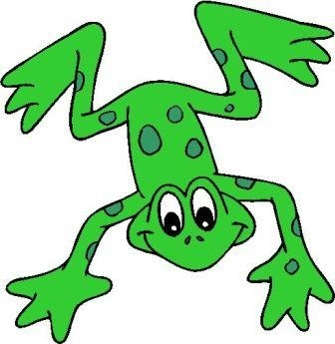
Fred talk
Fred is our Read, Write Inc. friend and mascot. He can only speak in sounds though, so we have to help him learn to say words, instead of sounds. For example Fred says 'c-a-t' instead of cat. We also teach him not to add 'uh' to our sounds in order to keep them pure. For example we say 'c' and not 'cuh'

Fred Fingers
We use 'Fred Fingers' to help make the transition between oral sounding out and spelling with magnetic letters or on paper.
Firstly we count how many sounds we can hear:
"cat, c-a-t, 3 sounds".
Then we hold up that many fingers.
For each sound we use our other hand to squeeze a Fred Finger and say the sound
"c-a-t".
Then we use our free hand to 'sweep' over our Fred Fingers and to blend the sounds into a word
"cat"

Watch out - words such as fish needs 3 Fred Fingers - "f-i-sh". Words such as flight need 4 Fred Fingers - "f-l-igh-t".

As children become more confident with their sounds and spelling words they will move away from using their Fred Fingers and instead rely on sounding out in their head.

Read, Write Inc. Books
During the phonic sessions, the children start to read a set of books which are only focused on the sounds which the children are learning/have already learned. Over the next few weeks, we will begin to send these books home as part of their daily reading at home.
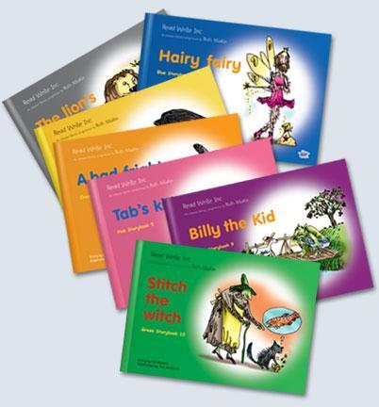
The children will have already read this book at school, but it is incredibly important that you continue to read it with them, and ask questions about the book (questions can be found at the back of the book) to ensure your child’s understanding. Please write in your child’s reading record about the RWI book, as well as any other books which your children are reading.

Remember: Reading should NOT be a challenge for children. We want to build their confidence, which is why we read it in school first.

Each colour band contains 10 main books. Children are taught to read the 'green' and 'red' words at the beginning of each book, before checking understanding using the 'vocab check' page. The children also talk about the upcoming story to make links to their own experiences before reading the book. They usually read the book 3 times. The first time is to practise decoding the words, the second time is to practise expression and fluency and the third time is to read for comprehension. Each book focusses on a particular sound or set of sounds, allowing the children to practise the sounds that they have been learning most recently. Adults will move their group through the books, picking and choosing books that they feel will best support the learning of their group.

Alien/monster/nonsense words
Research has shown that incorporating nonsense words into teaching reading can be an effective way to establish blending and segmenting skills. However, it is important to ensure that children understand that they are reading nonsense words (and why) so that they are not confused by trying to read the words for meaning. By reading nonsense words, children develop their ability to decode individual sounds and then blend them together to read. They are an indicator of early reading skills and work as a quick, reliable and valid way of assessing children.

Assessment
We have high expectations of every child at Eton Wick. We assess each child’s phonic abilities every 6 – 8 weeks, however, if a reading group leader thinks that a child has made very good progress, and has consolidated their learning, then they will be immediately re-assessed and moved to a group which matches their needs.

Phonics screening
At the end of Year 1, all children across the country are required to do a Phonics Screening check. This takes the form of 40 words, some of which are ‘real’ words and some of which are ‘alien’ words.
There will be a meeting in November to give further information about this.

