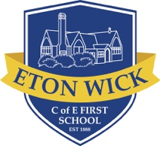
Eton Wick C of E First School
English Overview 2020 - 2021

Year 1
 | Autumn 1 | Autumn 2 | Spring 1 | Spring 2 | Summer 1 | Summer 2
Topic link | Rio de Vida | Moon Zoom | Bright lights, big city! | Splended Skies | Dinosaurs | Paws, Claws & Whisker
Book | 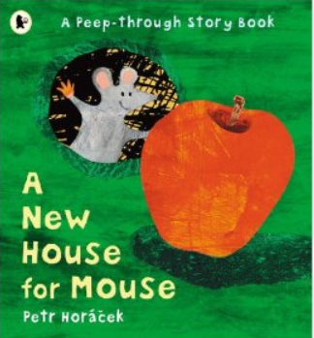  A New House for Mouse  Petr Horacek | 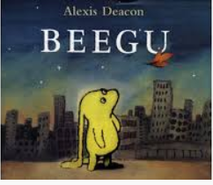  Beegu  Alexis Deacon | 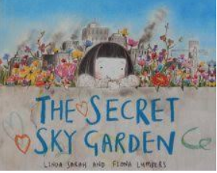  The Secret Sky Garden  Linda Sarah | 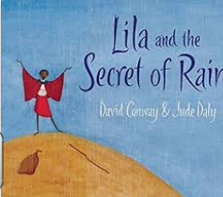 Lila and the Secret of Rain  David Conway | 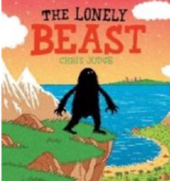  Lonely Beast  Chris Judge | 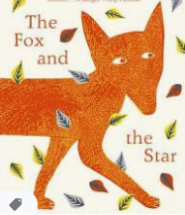  The Fox & the Star  Coralie-Bickford-Smith
Genre | Pattern & rhyme  -------  Responding to text | Labels, lists and captions | Instructions | Stories from other cultures  -----------  Poetry | Stories with a familiar setting | Narrative writing  ----------

