Eton Wick C of E First School
English Overview 2020 - 2021

Year 3
 | Autumn 1 | Autumn 2 | Spring 1 | Spring 2 | Summer 1 | Summer 2
Topic link | Metal | Volcanoes | Predators | Contrasting Locations | Pre-History | Greek Myths
Book | 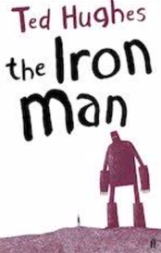  Iron Man  Ted Hughes | 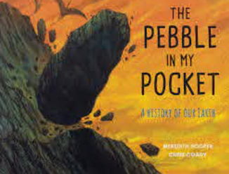  The Pebble in My Pocket. A History of Our Earth  Meredith Hooper | 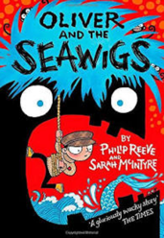  Oliver and the Seawigs  Philip Reeves  A range of non-fiction texts on predators | 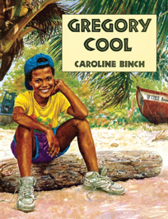  Gregory Cool  Caroline Binch | 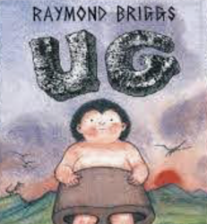  Boy Genius of the Stone Age  Raymond Briggs | 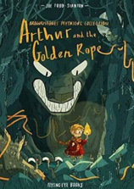  Arthur and the Golden Rope  Joe Todd-Stanton.  A range of Greek Myths
Genre | Persuasive letter  Diary Recount  Newspaper Report | Fact files  Writing in role  Diary entry | Instructions  Leaflets  Advert | Writing in role: Character descriptions  Biography  Narrative Descriptions | Non- Chronological Reports  Script  Postcard | Storytelling  Newspaper Article  Comic Book Writing

