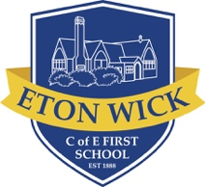
Eton Wick C of E First School
English Overview 2020 - 2021

Year 2
 | Autumn 1 | Autumn 2 | Spring 1 | Spring 2 | Summer 1 | Summer 2
Topic link | Street Detectives | Magnificent Monarchs | Muck, Mess and Mixtures | Wiggle and Crawl | The Scented Garden | Land Ahoy
Book | The Last Wolf  Mini Grey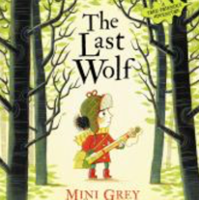 | The Princess and the White Bear King  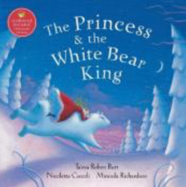  Tanya Robyn Batt | The Magic Finger  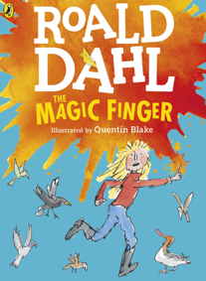  Roald Dahl | 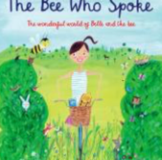  The bee who spoke by Al MacCuish | The secret Sky garden by Linda Sarah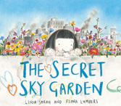 | 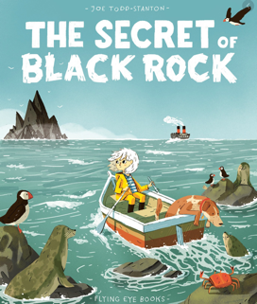  The secret of Black Rock
Genre | - Non fiction  - Letter writing  - Poetry | - Explanation  - Narrative  - Persuasive | - Letter  - Diary  - Information | Instructions  Diary entry  Information booklet | Persuasive writing  List poems  Narrative | Diary entry  Persuasion  Letters  instructions

